PARK SHELTER RESERVATION FORM
Name

Address

City | State, Zip
Phone | Email
Type of event

Number attending (200 or more see “Large Gatherings” on back of page)

Location Requested | Check One | Date of Event | Time of Arrival | Time of Departure
- Shelter in Habermann Park  $50 City resident / $60 non-resident | ☐
- Shelter in Goeres Park  $25 City resident / $35 non-resident | ☐

*I have read the rules and will be responsible for general cleanup and care of the facility and ensure compliance with all applicable City of Lodi park rules (see rules on back of page).

*Signature: ___________________________________________________________

Print Name: __________________________________________________________

City of Lodi Park Shelter Rules
- Reservations: Reservations may be submitted beginning January 1 for the current reservation year. Your shelter reservation entitles you to exclusive use of the shelter, but not the park. Shelter season runs from the second Saturday in May to the second weekend in October. Applications are available on the City’s website or at City Hall. Please note that Habermann Park Shelter is not available the 1st Saturday in July and the 2nd Saturday in August.

- Payment: Reservations are first-come-first serve and will not be held / confirmed until payment and signed application is received. Application and payment may be made in person at City Hall or by mail.

- Refunds: Fee is refundable if cancelled two weeks prior to the reservation date.

- Decorations /Carry-in: If you plan on decorating at the shelter, please make sure to only use adhesives that will not damage the shelter surfaces. Free-standing decorations are recommended. Nails, staples or glue are prohibited. After your event, please properly dispose of all of the decorations and return all tables and benches to their original location. No glass containers.

- Open/Close Time: The shelter may not be occupied before 7:00 a.m. and must be vacated by 10:00 p.m.

- Noise: No loud music or noise to disturb the peace.

- Large Gatherings: Gatherings of 200 or more must submit an application to the City Council for approval at least two months in advance.

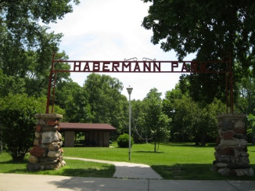  Shelter at Habermann Park | 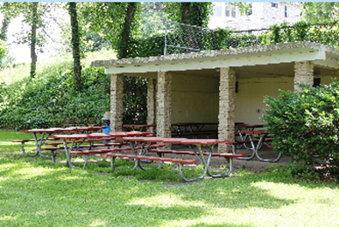  Shelter at Goeres Park

